**VALUE CREATION FROM B-GRADE RETURNS IN**

**E-COMMERCE**

**Student In Practice(SIP) Report**

**Fifth semester**

**M.Sc. International Technology Transfer Management**

by,

Name:- **Harnek Singh**

Matriculation number:- **121060129**

Supervisor :- **Prof, Dr. Stephan Schmitz**

Abstract

Value creation is focused on by firms to influence buying behaviour and retain customers. . This project aims at understanding ways in which value can be created in case of B-grade returns, at Clic-Trade GmbH, which is an international trading organization of Westhoven. Services and products of this trading company are sold directly to end customers. The goods return department at Clic-Trade works on the principle that in case of any defects in products, customers are eligible to return the products back to the warehouse.

This report helps to create a set of recommendations for organisations to improve the value creation from B- grade returns in E-commerce.

Table of Contents

1. Introduction 4

1.1 Analysing the core business exercises of value creation in organisation 4

1.2 Analysing the impact of e-commerce companies in the world of business 5

2. Methodology 5

3. Discussion 6

3.1 Defining the practices that B-grade management companies can use for creating value for the company 6

3.2 Analysing the pros and cons of a B-grade management company 9

Pros 9

Cons 10

3.3 Recommendation for improvement of B-grade in Clic-Trade GmbH 13

3.4 Theoretical Perspectives for value creation 16

Producer surplus maximisation theory 16

Value based management theory 16

Scientific management theory 17

4. Conclusion 18

References 19

# 1. Introduction

## 1.1 Analysing the core business exercises of value creation in organisation

Value creation is an important aspect of a business to improve the business outcome. Value creation for a business refers to a specific set of behaviour that helps a business to achieve its specific goals. The primary purpose of any business is to maximize the profit margin. Value creation is an essential base for any business to make it profitable and long-lasting. The core business exercise of value creation in an organisation includes providing every team member to share their personal views, exploring different meanings of the existing company values, and organising open communication about the organisation. Updating the mission statement of the organisation is also a helpful exercise for practising value creation.

The ***“value chain framework”*** is created out of five key activities: operations, outbound logistics, sales, inbound operations, and marketing. Moreover, four secondary activities are human resource management, purchasing/procurement, company infrastructure, and technological development. Value creation in e-Commerce emphasises specific logistics comprising shipping, inventory management, transportation, and warehousing that are essential for developing products and delivery to final customers. This exercise focuses on satisfying stakeholders by creating value for them with the product/services. For instance, if a product is purchased from a store or online the product quality, delivery time, and flexibility of making payment are the values created by e-commerce businesses.

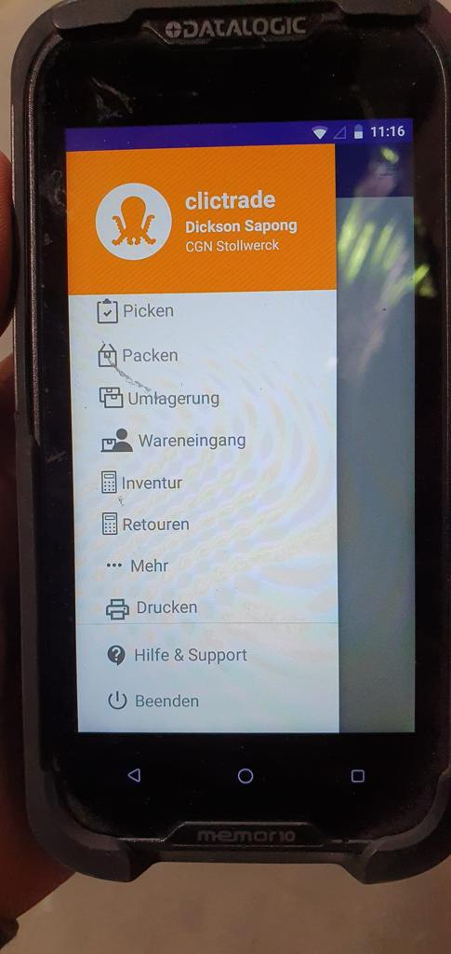

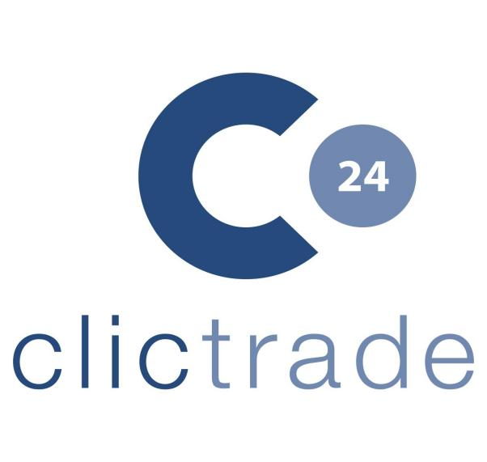

**Figure 1: Logo and app of Clic-Trade**

(Source: Clic-Trade, 2023)

## 1.2 Analysing the impact of e-commerce companies in the world of business

E-commerce companies are emerging in the business world these days. CLIC-Trade GmBH is an international trading company that uses b-grade marketing methods for conducting its business. This is also an E-commerce business that uses certain platforms such as Amazon, eBay, and many others. E-commerce companies can help a business to reach a broader audience. A company can have lower operational costs by applying e-commerce business strategies. Consumers can also shop more confidently from e-commerce websites as they get the opportunity to compare items. Traditional shopping increases business costs in comparison to the E-commerce business.

E-commerce companies are significantly responsible for stimulating economy of a particular country by encouraging innovation, improving shopping experience, and encouraging innovation. Thus, indicating that the use and growth of e-commerce businesses have the ability to boost the country's economy. E-commerce expands the marketplace in both international and national countries irrespective of operational areas impacting the revenue growth of an entire country. This happens due to increased payment of taxes leading to GDP growth. However, e-commerce companies also impose a negative impact concerning growth of competitive business markets. E-commerce operations being more cost-effective due to elimination of store maintenance costs are capable of offering products at lower costs attracting and retaining more customers in comparison to physical brick-and-mortar stores.

# 2. Methodology

This study has been conducted by undertaking ***“Interpretivism research philosophy”*** as it best supports evaluation of existing data and theories. Prevailing literature can be suitably aligned with recent trends to develop an elaborate understanding. This philosophy has supported identifying the core value creation business exercise and incorporating information concerning the impact of e-commerce companies. ***“Case-study research approach”*** has been undertaken as this approach enables incorporation of factual data by eliminating all non-relevant and non-essential information highlighted in the selected case study. Case-study approach helps ineffectively analysing and interpreting the existing information to construct a high-quality research study (Park *et al*. 2020). ***“Descriptive research design”*** has been used as it supports identification of each key variable included in a case study to enhance the quality and understanding of the study. This research design has enabled incorporation of knowledge concerning B-grade management creating value for Clic-Trade to eliminate its key ***issue of returns*** in recent years.

Additionally, ***“Secondary data collection method”*** is undertaken by gathering data from numerous secondary sources like peer-reviewed articles, authentic websites, and news. Secondary data enables incorporation of existing literature and information concerning the study which enhances the understanding of the study or research topic (Santoro *et al*. 2019). Secondary data collection has facilitated efficient evaluation of the case study regarding B-grade business value creation of Clic-Trade to incorporate authentic and most significant data relevant to the study. ***“Qualitative research strategy”*** has been used as it best supports secondary data collection and interpretation of data, permitting elaboration of each aspect of the case study (Vindrola-Padros and Johnson, 2020). A qualitative research strategy aligned with ***“Case-study data analysis technique”*** has led to identification of core issues faced by Clic-Trade in managing its B-grade value creation. Databases like Google Scholar and Pro Quest have been used for extracting authentic and freely accessible articles relevant to the study.

# 3. Discussion

## 3.1 Defining the practices that B-grade management companies can use for creating value for the company

B-grade Management Company refers to those organisations which use specific platforms for selling their products. These organisations collect returned goods and check whether there are any defaults. After finding the default, these organisations make the condition of the product proper and deliver them to consumers.

***Offering high-quality products***

B-grade management creates value for Clic-Trade in various ways like offering high-quality products, improving cash flow, and diversifying customer base. B-grade management enables ***offering high-quality products*** by streamlining the resources more efficiently through resource management tools like Forecast, Paymo and Scoro to significantly identify resource requirements and flow (Strezoski, 2023). Efficient resource allocation and usage help in developing high-quality products due to restricted manufacturing depending on the demand for the product/service in the market. Additionally, efficient resource allocation also leads to improvement of financial structure of the business due to elimination of excess production costs and appropriate usage of resources. B-grade also ensures effective scalability demonstration that supports efficient and sustainable usage of resources leading to development of high-quality products. Therefore, indicating that B-grade ensures offering high-quality products and is also a significant way in which it creates value for Clic-Trade.

***Diversifying customer base***

Application of B-grade management can suitably result in diversifying the customer base through technological interventions like identifying the damaged or missing products and resending the product with the missing product. Allocating and managing potential customers through digitalised record-keeping creates value for Clic-Trade GmbH in providing improved services to its customers. According to Dong and Yang (2020), diversification of customer base ensures that the business establishes itself as a service-providing organisation leading to attainment of a competitive edge. Diversifying customer base also enhances brand awareness resulting in effective ***“word of mouth marketing”*** influencing sales and revenue growth of the business. Thus, influencing value creation of customer base diversification for Clic-Trade, promoting business growth and eliminating ***stock return issues*** faced by the company in recent years.

***Providing competitive advantage***

B-grade by enabling customer diversity, retention, and opening doors for technology advancement adoption creates value for Clic-Trade by providing a competitive advantage (. Resolving the issue of missing or damaged products increases customer satisfaction leads to customer retention growth. This, in turn, increases customer interaction and repeat purchases from Clic-Trade supporting its financial/revenue growth. According to Goulas *et al*. (2022), B-grade by eliminating the STEM gap which is the depreciation between production quantity and demand in the market generates value of operational stability leading to attainment of competitive advantage. Influencing development of overall operational efficiency through customer expectation identification initiates financial value creation for Clic-Trade. As analysed, Clic-Trade has succeeded to achieve *technical mastery with a human touch* (Clic-Trade, 2023). This has been possible due to its dedicated trading platforms with world-class support and security for a company to enrich trading experience. It offers two trading platforms, each of which are designed to make the journey through financial markets remarkable and efficient.

***Demonstrating Scalability***

B-grade also provides the opportunity of demonstrating scalability to customers and other stakeholders by Clic-Trade. This enables the business to not only generate revenue but also to grow without being restricted by its lack of resources or by its structure. Primary thing that should be kept in mind while scaling the business is to determine the need of the market for one's services or products. It is necessary to consider during scaling a business whether the service or products are capable of solving an issue or what is the market potential for the service or product. The second thing is that a system which can support the business as it grows needs to be implemented (Gowal*et al.* 2019). Lack of help from these systems, the business may not be able to meet demands as it grows. Demonstrating scalability is important to build a strong sales team, administration team and customer service team. Therefore, B-grade by enabling demonstration of scalability by Clic-Trade has created significant value for the businesses by improving customer engagement.

***Cash flow improvement***

B-grade has led to creation of value for Clic-Trade by improving its cash flow through identification of missing or damaged products and resolving the issue of its customers. According to Christensen *et al*. (2022), serving customers in a more effective way has also resulted to increase in customer retention rate and eliminate the issue of customer dissatisfaction. Improving cash flow for small firms is considered to be challenging. However, solving minor issues can help one to take out the stress and enable them to avail some financial breathing room. Managing the cash flow may not solve the existing issues but helps to gain a stronger footing in the long run.

Cash flow can be improved in several ways but the most effective methods are negotiating in quick payment terms and B-grade. As argued by Ivanov *et al*. (2022), businesses need to ensure that customers must make the payment on time or they would be placed in a negative shortage of time flow. Giving customer's incentives like discounts on orders made in future, gifts or something else if they make the payment early would help in improving cash flow and retaining customers as well. Cash flow improvement enhances the entire financial structure of Clic-Trade, thus, creating value for the organisation’s financial growth through B-grade services.

***Efficient financial controls***

***“Clic-Trade GmbH”*** is an international trading company which is a self-development brand combining current trends with customer demand. Financial controls are procedures and policies which aim to detect fraud or accounting errors and prevent them. As quoted by Lartey *et al*. (2020), financial controls are widely divided into detective controls and preventive controls. Preventive controls help in prevention of errors and frauds from occurring at all, while detective controls help in catching errors which have crept into the financial procedures. Corrective controls may be used to correct such errors detected by detective controls. The deposit of double counting cash is one of the preventive controls in which the payment is reflected by both the payee and the receiver. Comparison of actual and expected results is important to ensure effective financial control. Additionally, as stated by Moretto and Caniato (2021), triple matching of invoices, purchase orders and payments also plays a crucial role in increasing efficiency of financial control. Hence, indicates that B-grade facilities/services create value of efficient financial control for Clic-Trade.

## 3.2 Analysing the pros and cons of a B-grade management company

### Pros

**Building sustainable customer relationships**

B-grade services enable Clic-Trade to resolve the issue of ***“stock return”*** by customers due to missing or damaged products. The company through this service ensures replacement of the products in open parcels and sends them back to customers after replacing the product. According to Wahyudin and Hasibuan (2019), the effective replacement and prompt resolution of the issue enable the company to keep its customers engaged leading to building sustainable customer relationships. B-grade management is especially useful in customer retention and developing sustainable customer relationships. In context to case study provided, the products sent by the customers are either existing damage, the products got damaged during the shipment or the products were intentionally damaged by the customers in such a way that cannot be pointed out. Irrespective of reason for product missing or damaged, Click-Trade replaces or adds the products to open parcels for fulfilling customer needs or expectations. Effective B-grade approach enables Clic-Trade to develop sustainable relationships with its customers fulfilling their expectations and engaging them with the company. This enables, the company to improve its financial structure in return through improved sales. The company also aims at increasing its loyal customer base by using B-grade to promote customer interaction in a more efficient and effective manner. Sustainable relationship building with customers also permits Clic-Trade to attain a competitive edge in attaining repetitive sales from its loyal customer base.

**Enhancing customer satisfaction**

B-grade approach helps enhance customer satisfaction since it involves replacement of damaged packages whether it was due to the fault of the firm or due to negligence of the customer. According to Pei *et al*. (2020), customers usually seek satisfaction when they get a product or service that not only satisfies their needs but also does a bit extra to make them feel that it is worth their payment. However, if the customer receives a product, especially one which costs more than other existing choices, that is non-functional or damaged even in the slightest manner, they feel the urge to get a refund or exchange for the service. As argued by Vindrola-Padros and Johnson (2020), refunding a complete amount of money would be a much greater loss to a firm b-grade management enables it to serve the same function by reducing the loss. This is because the firm is able to rectify the defective product and correct it to use the product for a different service. Therefore, Clic-Trade can attain revenue growth through sales from satisfied customers willing to purchase repetitively from the same brands considering their service efficiency.

**Increasing market positioning and awareness**

Customers in today’s era, especially the younger generation, look for service over product price due to increasing pocket size. The increasing income of youth globally has led to the generation of an environment where customers look more for service and product quality irrespective of its pricing. Therefore, Clic-Trade through B-grade approach has established effective relationships with its customers. This, in turn, has benefitted the company with improved market positioning and awareness due to its unique service delivery.

### Cons

**Additional costs imposed on Clic-Trade**

The replacement of damaged products and the addition of the missing ones in the open parcels impose additional product procurement, manufacturing, packaging, and delivery costs. Additional costs incurred on Clic-Trade restrict its financial performance and growth imposing a negative impact on organizational productivity. The cost of shipment is also imposed on Clic-Trade due to delivery services of the products after replacement. However, the additional service costs are balanced by repeat orders from loyal customers. The additional cost imposed on the business also restricts its financial market growth which is a significant negative impact imposed by B-grade approach adopted by Clic-Trade. This has also led to minimising the productivity of the company by restricting resource investment. Moreover, sustainable resource allocation is also restricted due to B-grade approach as it limits the cash flow at a certain point in time.

**Disrupted trading services**

Application of B-grade approach has infused disrupted trading services due to replacement of damaged products and addition of the missing products in open parcels. Clic-Trade while conducting its businesses in operating process of testing products and identifying cause of its damage and missing simply focus on satisfying their customers. However, this improves customer relations but disrupts the trading services of the company due to repetitive deliveries. According to Palmiéet *al*. (2020), the stock returns have been significantly increasing in recent years due to which the operational costs of the company have also grown significantly. Trading services of Clic-Trade is its primary operation for which it essentially has to focus on trading services efficiency. On contrary, B-grade influences operational decisions of Clic-Trade concerning its production, packaging, maintenance, and delivery. Hence, imposing a critical impact on disrupted trading services offered to company. Trading services are also distributed by extensive parcels accumulating in warehouse of the company for return and exchange, blocking the space for storage of fresh products that are manufactured. However, it is analysed that Clic-Trade has been facing numerous issues related to parcel returns and hence, essentially needs to improve its services through B-grade to build sustainable customer relationships.



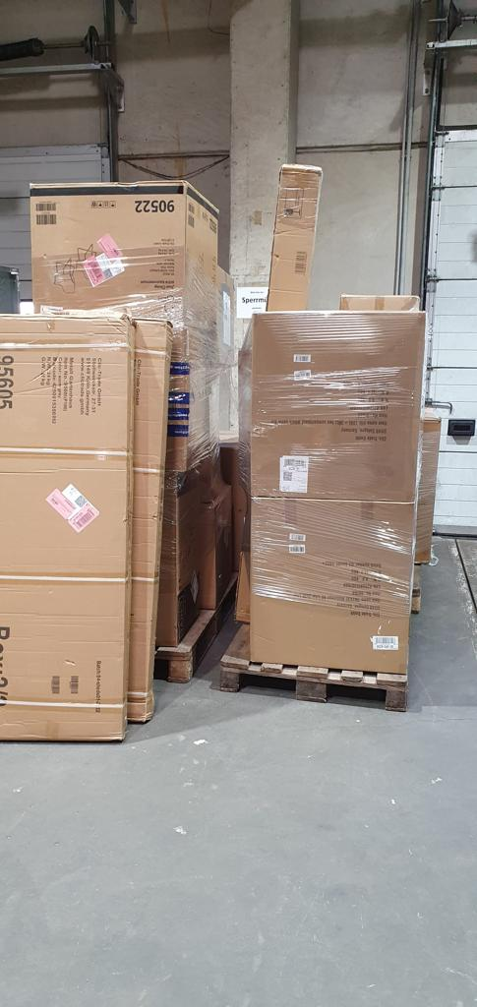**Figure 2: Return of products to Clic-Trade by customers due to missing or damaged products**

**Figure 3: Increasing number of parcel returns restricts cash flow of Clic-Trade**

**Lack of resources**

The extensive return and replacement of the products offered by Clic-Trade have resulted in a lack of resources. This is because of lower production rate in comparison to demand or stock return being received by the company in recent years. As stated by Prata *et al*. (2019), lack of resources is also a significant cause due to increasing raw material costs as an impact of COVID-19 pandemic. However, Clic-Trade is a profitable business to date due to its unique service offering and strong customer base. Thus, application B-grade approach has imposed restrictions on resource availability but supports constant business and sales growth of Clic-Trade.

The organisation for establishing an effective B-grade approach needs to incorporate sustainable resource allocation facilities and elaborate its production, increasing its capacity. As opined by Goulas *et al*. (2022), increasing number of returns might not always cause lack of resources if it is efficiently balanced through increasing production capacity. This can also lead to improved service offerings concerning both fresh product and replacement product demands. Furthermore, Clic-Trade has a competitive advantage of a significant loyal customer base and increasing repetitive orders (Clic-Trade, 2023). The organisation has developed sustainable customer relationships which permit it to receive repetitive fresh orders adding to its revenue increment.

## 3.3 Recommendation for improvement of B-grade in Clic-Trade GmbH

Value creation from B-grade returns in E-commerce is an important aspect to reduce product returns. E-commerce returns are considered to be an ongoing problem for every online based business. Therefore, value creation from B-grade returns in E-commerce for the company Clic-Trade GmbH is important to enhance their production. A large number of the population specifically after the pandemic has moved to online platforms and online shopping. Therefore, companies need to undertake effective strategies to deal with their returns in E-commerce. The goal of the company, Clic-Trade GmbH is to meet the expectations and demands of their customers and create value in their supply chain through increasing their profit margin.

***Implementing a liberal return policy*** will help customers to put their trust into the company and purchase goods confidently. It can be determined that with a liberal return policy the company can benefit from increased loyal customers and can effectively gain their trust into ordering the product. Based on the study of Climent and Haftor (2021), the key to achieve success in e-commerce e business is to gain consumer trust. Thus, liberal return policy helps consumers to make confident decisions on purchasing products because they have the faith to return the product in case it does not fit to their expectations. Hence, this may inflict an increased number of orders for the company Clic-Trade GmbH. It has been identified from a survey that approximately 69% of consumers do not place orders from brands which do not have an easy return policy (Informs.org, 2021). Hence, it can be determined that implementing a liberal return policy will help the company to gain the trust from their consumers.

***Focusing on detail-rich product descriptions*** also has its significant contribution in fulfilling the demands and expectations of consumers. It has been figured that the majority of the online traders fail to meet the details that were provided in the product description. Therefore, it is recommended that Clic-Trade GmbH employees might consider putting immense effort on filling each and every detail that were put into the product description in order to fulfil the expectations of the receivers. Furthermore, creating attractive product bio is important for generating interest of consumers. Additionally, using a detailed and thorough description about products is also important. This will further help in mitigating disruptions in their trading and will enhance their number of bulk orders.

***Implementing a dynamic range of a variety of products*** will help the company to provide different segments of a particular product category. Especially for B-grade companies, it is important to have a range of variety of products in order to effectively manage value in their supply chain and trade with different consumers. Based on the study of Hamilton *et al.* (2019), having a variety of options attracts consumers to choose from and helps bring their interest into the distributor. Furthermore, it has been identified that ***elevating the value of consumer reviews*** will help in improving the reputation of the company and will also help in determining consumer feedback regarding their service.

***Segregating accounting duties*** will help the company to determine cash flow more efficiently. For example an accounting officer will help in managing financial aspects of the company. It has been identified that the company needs an effective accounting manager which will help in determining the cash flow of the company and will effectively manage the returns in e-commerce. According to the study of Dźwigoł (2019), restructuring access to financial systems for other employees in the company will help prevent any kind of financial risk from engineering. Therefore, the company might consider giving the access to the financial transactions and systems to the particular employees with their certain rights.

The company might also consider implementing an ***effective budgetary system*** in order to reduce their additional expenses which are impacting their budget. Moreover, conducting a thorough analysis of their additional expenses and shifting to cost effective methods will help the company to reduce their additional expenses.

***Promoting exchanges instead of returns*** will also help the company to reduce returns and improve their trading business. It has been identified that the company is facing certain disruptions in their trading business. Based on the study of Baryannis*et al.* (2019), implementing risk assessment will help in mitigating any kind of uncertainties and emerging risks within a business operation. In terms of creating value in their e-commerce business the company might consider completing a risk assessment. Therefore, it will not only help the company to identify certain potential risks which can harm and disrupt trading but also helps in creating effective strategies to further improve their services. Hence, it can be recommended for Clic-Trade GmbH is to implement effective leadership management which will determine optimum productivity of the employees and will also help in leading team members to meet the goal of the business.

***Conducting market research and development*** will help the company to access crucial information about the demand and trends of the market which the company needs to meet in order to increase their profit margin. Based on the study of Dieppe (2021), market trends and innovation causes major disruptions in the businesses and causes significant problems while complying with the market needs. Hence, Clic-Trade GmbH might consider conducting market research and maintain continuous development which will help the company to support innovations within the company operations.

Another major recommendation for the company is to consider ***implementing advanced technology*** such as Artificial intelligence, Machine learning, and cloud computing, big data analytics and IoT in order to improve their operation. According to the study of Albukhitan (2020), advanced technologies help companies to digitally transform and adapt effective strategic approaches which will determine success for and help in gaining sustainability in the evolving environment. Implementing effective and advanced digital technologies will not only help the company to determine cash flows efficiently but also help in maximising the performance level. Thus, advanced technologies will help Clic-Trade GmbH to enhance their productivity level and will also help in meeting the needs of their consumers along with reducing risks which has the potential of harming the business.

## 3.4 Theoretical Perspectives for value creation

### Producer surplus maximisation theory

Producer surplus maximisation theory defines the total amount that a manufacturer or producer benefits from producing a significant amount of goods and selling them at a market price. Product surplus is defined as the total revenue of a company which it gains from selling a product minus the marginal cost. Based on the study of Deconinck and Swinnen (2021), producer surplus maximisation theory derives that companies need to maximise their profit margin in order to gain more revenue and success. Therefore, as per the theory perspective the company might consider implementing an effective accounting management system which will efficiently calculate their profit margin and the company can take certain decisions as per their producer surplus.

The company might implement the theoretical perspectives for improving their service quality and enhancing their profit margin via enhancing the productivity of their employees and workers. As per the theory it has also been determined that harmony in work and cooperation are the major elements of effective management. Thus, bringing more collaboration of the team members and increasing their effectiveness in contemplating and cooperating with other co-workers is important for effective communication which further significantly contributes in maximising the performance level.

### Value based management theory

Value based theory determines the interconnectedness between internal and external managerial activities which will help in creating value. Furthermore, it has been determined that the theory suggests building interconnectedness between activities which will further increase the acceptance level of relevant organisational values internal and external. According to the study of Komara *et al.* (2020), value based management theory helps to determine human values at the core of an organisation's management. Thus, it suggests taking care of the workers and maintaining their well-being will help create valuable outcomes which will further help in determining certain effective outcomes. Additionally, the company Clic-Trade GmbH might consider creating a diverse working culture and increasing the brainstorming skills of their works in order to create value in their service quality. Furthermore, it has been determined that increasing the effectiveness of the employees will further help the company to enhance their customer service which will further help in value creation in their b-grade E-commerce business. Moreover, the theory depicts that management of an organisation might consider focusing on creating corporate value in order to enhance their productivity level and effective management. Therefore, managers of Clic-Trade GmbH need to implement an effective leadership approach which will help meet the objectives of the theory to establish an effective business in the complex and competitive environment.

The theory also aims to increase shareholder value and a consistent development through innovation which will ensure sustainability in the long run. Moreover, it can be determined that the theory helps to determine the importance of creating value through implementing effective resources and value based strategies within an organisation to achieve success. Therefore, the theory determines the ways that the company can increase creating value within their organisation. Thus, it will help in increasing the consumer satisfaction level through the help of valuable integration of internal company activities.

### Scientific management theory

Scientific management theory is defined as an effective management theory which tends to improve economic efficiency through analysing and synthesising workflows. Based on the study of Braverman (2020), the principles of scientific management theory depict bringing the best quality out of the workers. Frederick Taylor introduced scientific management theory in 1909. The theory depicts that a company should; take the responsibility of the failures and success both. Additionally, maximising the workers productivity is the key to achieve success and bring economic efficiency. Hence, as per the theory the company might consider providing training to its employees in order to increase their effectiveness and motivation regarding accomplishing each task. Furthermore, Clic-Trade GmbH might consider effectively managing workloads in order to prevent distress. Thus, it will help in increasing the effectiveness and engagement of their workers. Burnett and Lisk (2019) stated that engaged employees tend to put more value in their productivity. Hence in this case as the company tends to create value in their B-grade e-commerce business might consider effectively focusing on the productivity and efficiency level of their employees. Hence, it can be determined that as per the theory each worker must be given standard conditions and appliances which will help them in accomplishing each task efficiently.

# 4. Conclusion

The study concludes that value creation in B-grade returns in E-commerce business is important in order to maximise the profit margin. The research helps to determine certain ways that can be deployed by the company to increase their productivity level and mitigate certain issues which tends to impact significantly in their operation and disrupts trading. It can be determined that the study also identifies certain pros and cons of b-grade and identifies effective strategies and recommendations to mitigate any kind of emerging issues within the organisation. The company tends to maximise their profit margin through meeting the demands and needs of the consumers. Clic-Trade has significantly experienced growth in product return that is disrupting its operations in recent years. However, the incorporation of B-grade approach has supported sustainable development of customer relationships leading to increased repetitive sales.

B-grade is a newly introduced service for replacing or adding products that are damaged or missing consecutively from the stock that has been returned by customers of Clic-Trade. The open parcels are rechecked and evaluated for missing parts or products, replaced, and then sent for delivery. This study concludes that the B-grade approach has imposed more positive impact in comparison to negative impact on growth of Clic-Trade’s revenue and financial performance structure. The incorporation of new B-grade approach by the company for improving customer satisfaction has been effectively managed and aligned with increasing production capacity of the company along with increasing demand for its products both fresh and replacement. B-grade service has benefitted Clic-Trade with efficient financial control through improved customer engagement and satisfaction. Improving cash flow and demonstrating scalability are two significant ways in which B-grade has benefited Clic-Trade to not only improve its operational efficiency but also build sustainable customer relationships. Diversifying customer base and providing competitive advantage have also been initiated by B-grade as advantages for Clic-Trade. In addition, it has also been assisting this company in upgrading its services by emphasising on needs and necessities of customers in an effective manner creating a major impact on organisational sales.

# References

Albukhitan, S., (2020). Developing digital transformation strategy for manufacturing. Procedia computer science, 170, pp.664-671.

Baryannis, G., Validi, S., Dani, S. and Antoniou, G., (2019). Supply chain risk management and artificial intelligence: state of the art and future research directions. International Journal of Production Research, 57(7), pp.2179-2202.

Braverman, H., (2020). Scientific management. In Industrial Work and Life (pp. 111-127). Routledge.

Burnett, J.R. and Lisk, T.C., (2019). The future of employee engagement: Real-time monitoring and digital tools for engaging a workforce. International Studies of Management & Organization, 49(1), pp.108-119.

Christensen, P.H., Robinson, S. and Simons, R., (2022). Institutional investor motivation, processes, and expectations for sustainable building investment. *Building Research & Information*, *50*(3), pp.276-290.

Clictrade. (2023). *Trading platform.* Available at: https://clicktrades.com/trading-platforms [accessed on 16.02.2023]

Climent, R.C. and Haftor, D.M., (2021). Value creation through the evolution of business model themes. Journal of Business Research, 122, pp.353-361.

Deconinck, K. and Swinnen, J., (2021). The size of terroir: A theoretical note on economics and politics of geographical indications. Journal of Agricultural Economics, 72(1), pp.321-328.

Dieppe, A. ed., (2021). Global productivity: Trends, drivers, and policies. World Bank Publications.

Dong, J.Q. and Yang, C.H., (2020). Business value of big data analytics: A systems-theoretic approach and empirical test. *Information & Management*, *57*(1), p.103124.

Dźwigoł, H., (2019). The concept of the system approach of the enterprise restructuring process. Virtual Economics, 2(4), pp.46-70.

Goulas, S., Griselda, S. and Megalokonomou, R., (2022). Comparative advantage and gender gap in STEM. *Journal of Human Resources*, pp.0320-10781R2.

Gowal, S., Dvijotham, K.D., Stanforth, R., Bunel, R., Qin, C., Uesato, J., Arandjelovic, R., Mann, T. and Kohli, P., (2019). Scalable verified training for provably robust image classification. In *Proceedings of the IEEE/CVF International Conference on Computer Vision* (pp. 4842-4851).

Hamilton, R., Thompson, D., Bone, S., Chaplin, L.N., Griskevicius, V., Goldsmith, K., Hill, R., John, D.R., Mittal, C., O’Guinn, T. and Piff, P., (2019). The effects of scarcity on consumer decision journeys. Journal of the Academy of Marketing Science, 47, pp.532-550.

Informs.org (2021), *Consumer Return Policies in Omnichannel Operations;* Available at: https://pubsonline.informs.org/doi/abs/10.1287/mnsc.2019.3492 [Accessed on: 11th February, 2023]

Ivanov, S.H., Webster, C., Stoilova, E. and Slobodskoy, D., (2022). Biosecurity, crisis management, automation technologies and economic performance of travel, tourism and hospitality companies–A conceptual framework. *Tourism Economics*, *28*(1), pp.3-26.

Komara, A., Ghozali, I. and Januarti, I., (2020), March. Examining the firm value based on signalling theory. In 1st International Conference on Accounting, Management and Entrepreneurship (ICAMER 2019) (pp. 1-4). Atlantis Press.

Lartey, P.Y., Kong, Y., Bah, F.B.M., Santosh, R.J. and Gumah, I.A., (2020). Determinants of internal control compliance in public organizations; using preventive, detective, corrective and directive controls. *International Journal of Public Administration*, *43*(8), pp.711-723.

Moretto, A. and Caniato, F., (2021). Can Supply Chain Finance help mitigate the financial disruption brought by Covid-19?. *Journal of Purchasing and Supply Management*, *27*(4), p.100713.

Palmié, M., Wincent, J., Parida, V. and Caglar, U., (2020). The evolution of the financial technology ecosystem: An introduction and agenda for future research on disruptive innovations in ecosystems. *Technological forecasting and social change*, *151*, p.119779.

Park, D., Bahrudin, F. and Han, J., (2020). Circular reasoning for the evolution of research through a strategic construction of research methodologies. *International Journal of Quantitative and Qualitative Research Methods*.

Pei, X.L., Guo, J.N., Wu, T.J., Zhou, W.X. and Yeh, S.P., (2020). Does the effect of customer experience on customer satisfaction create a sustainable competitive advantage? A comparative study of different shopping situations. *Sustainability*, *12*(18), p.7436.

Prata, J.C., Silva, A.L.P., Da Costa, J.P., Mouneyrac, C., Walker, T.R., Duarte, A.C. and Rocha-Santos, T., (2019). Solutions and integrated strategies for the control and mitigation of plastic and microplastic pollution. *International journal of environmental research and public health*, *16*(13), p.2411.

Santoro, G., Fiano, F., Bertoldi, B. and Ciampi, F., (2019). Big data for business management in the retail industry. *Management Decision*, *57*(8), pp.1980-1992.

Strezoski, L., (2023). Distributed energy resource management systems—DERMS: State of the art and how to move forward. *Wiley Interdisciplinary Reviews: Energy and Environment*, *12*(1), p.e460.

Vindrola-Padros, C. and Johnson, G.A., (2020). Rapid techniques in qualitative research: a critical review of the literature. *Qualitative health research*, *30*(10), pp.1596-1604.

Wahyudin, B.I.S. and Hasibuan, S., (2019). Analysis for enhancing quality and productivity using Overall Equipment Effectiveness and statistical process control in manufacturing industry case study: Manufacturing industry sport shoes in Tangerang region. *International Journal of Innovative Science and Research Technology*, *4*(12), pp.108-114.